News Classifier
High Level System Architecture
and
System Module Definition Document

Table of Contents

Table of Contents
Table of Contents 2
Introduction 3
High Level Architecture Diagram 3
Module Type and Object Containment 4
Manager Dependencies 5
Module Requirements Mapping 5
Detailed system architecture: 6
2. Size 7
3. Performance 7
4. Limitations 7
4. Other references 8
5. Conclusion 8
Appendix A – Working within Docker container boundaries 9
Appendix B - Programming Python with Kafka, zookeeper, spark 11

Introduction

This document contains the high level architecture for the News Classifier system. To describe the system at a high level, modules containing related low-level objects and functionality have been defined. The document then defines each module’s responsibilities and inter-dependencies. Additionally, for completeness, each of the project requirements has been mapped to a particular module.

High Level Architecture Diagram

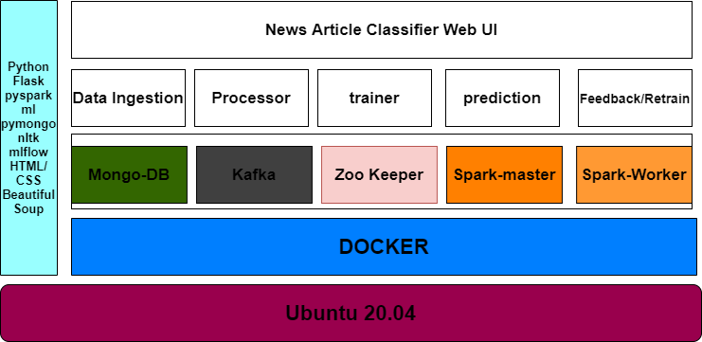

Module Type and Object Containment
The table below lists the system modules, their binary type, the objects that are contained within the module and a generalized bullet list of responsibilities for the module.
- All the modules are containerized and are of docker image format.
- Python programs and modules will have the .py extension
- MongoDB files will be stored with .json format.

Module Name | Binary Type | Objects Contained within module | Responsibilities
Kafka | Docker image | Kafka, zookeeper | Responsible for creating topics and streaming the messages for the topic to the broker.
Zookeeper | Docker image | Zookeeper | It will maintain the list of all active topics in the Kafka broker.
Producer | Docker image | Kafka, Spark | This program will fetch the data from freenewsapi, filter the required data from the response, connect to the kafka server, and stream messages to a specific topics in the json format.
Consumer | Docker image | Kafka, Spark | This program will retrieve the json messages from the kafka broker and will store the raw data into the mongo db
Database | Docker image | Mongo DB | The Mongo DB service that will start an instance of the Mongo server and will listen to the requests from the clients.
Spark-master | Docker image | Spark | Will launch the producer/consumer data ingestion applications as spark worker thread.
Spark-worker | Docker image | Spark | Will execute the task submitted by the spark master.

Naming Convention: All the python PEP programming naming conventions were followed.
Also, the docker/docker-compose conventions were followed for all the docker images.

Tools – Denotes a generic set of utility functionality used by several sub-systems.

docker, docker-compose, zookeeper, kafka, mongodb, mongodb express, spark, python, Flask UI with HTML and CSS,
Beautiful Soup, pyspark ml libraries for model processing, training and predictions pipelines, mlfow.

Manager Dependencies
The table below lists the top-level system modules (a.k.a. Managers) and their interdependencies. The third column is a possible interface prototype to represent the needed module entry point for the identified dependency.

Module Name | Dependency | Interface needed
Zookeeper | None | Will run as a service in the docker container on Port 2181
Kafka | Zookeeper | Will connect to the zookeeper before initialization. This will also run as a service on Port 9092
Spark-master | None | Will run as a service on External Port 8080/Internal Port 7077
Spark-worker | Spark-master | Will run as a service on port 8081
Producer | Spark-master, Kafka, MongoDB | Will run as a service and run as a spark worker thread.
Consumer/ Prediction Service | Producer | Will run as a service and run as a spark worker thread.
Training Service | Producer | Will run as a service and run as a spark worker thread.
Feedback Service | Prediction Service, Training Service | Will run as a service and run as a spark worker thread.
MongoDB | None | Will run as a service on Port 27017

Module Requirements Mapping
The table below lists the system modules and a list of numbers. This correlation represents the module who “owns” the feature implementation. Duplicated or overlapping numbers means that the modules share the requirement, and both have the responsibility of ownership.

Module Name | Requirements Mapping
Producer | kafka, pathlib, time, bson, os, sys, requests, mongo client
Consumer | kafka, json, time, pathlib, os, sys, mongo client
Processr | Pyspark, pyspark.ml, beautiful soup, mlflow, basic python libraries
Flask UI | Flask API, HTML/CSS

Detailed system architecture:

Below is the detailed system architecture diagram:

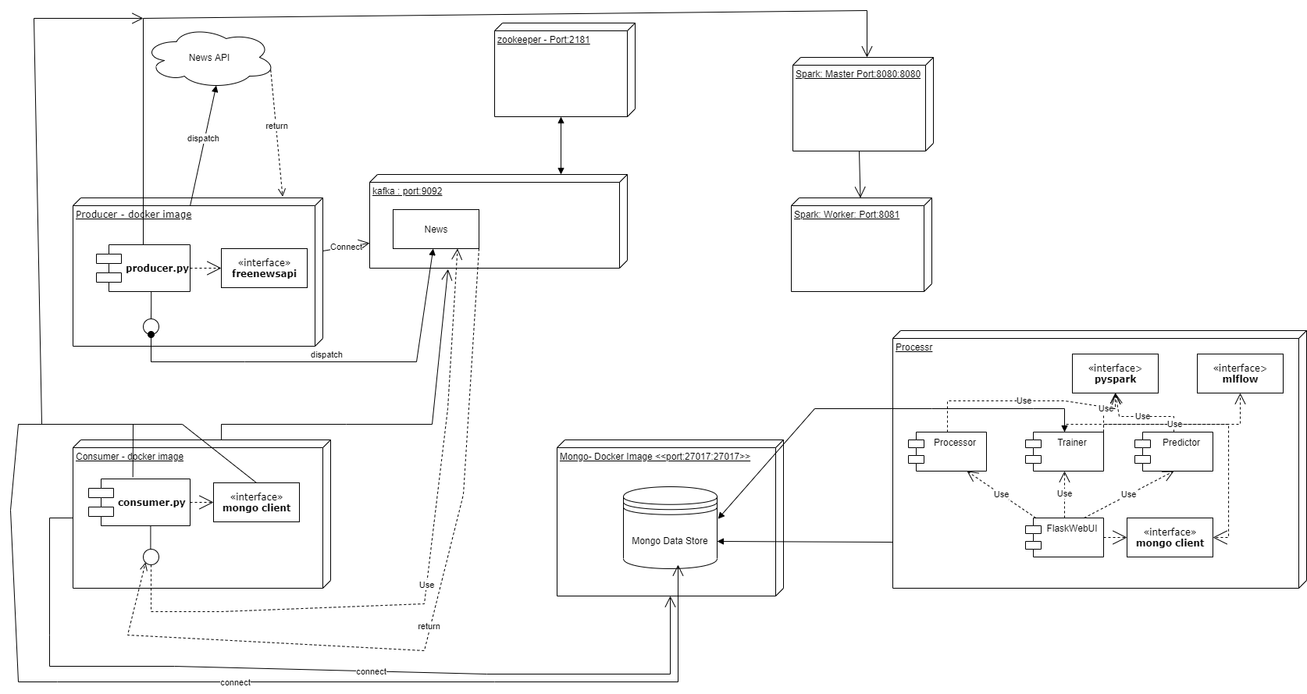

2. Size

All the sizes of the docker images depends on the requirements for the image. As of now, we could see the total size of the implementation needs 30 GB of disk space.

3. Performance

As, we are dockerizng the application modules, there will not be a much performance degrade while building and launching the separate docker images. Once, the docker images are ready we have orchestrated then using the docker-compose. Each image is launched separately as a docker process. These docker process will have the docker containers running inside which will host the target image. Specific ports were exposed from the container to enable the communication between different docker containers. The Docker-compose is so fast and will make all the containers up an running and make them available for any client application.

4. Limitations

1. Currently the news classifier implementation was trained for only the below categories only. This could be extended further to predict other categories too by retraining the model with more categories:
1.Business 2. Sports 3. Science and 4. World.
2. Current implementation, uses the spark master only for data ingestion. The data training and feed back are not using the spark master to run the spark jobs due to the resource constraints. We implemented but that gave the resource constraint errors when we ran. This could be tested on a spark cluster that have more computing capabilities and space.
3. We have implemented the ml flow for storing the trained model into the mflow registry. But when we ran it in our local machine, it gave some resource errors. We tried with different versions of ml flow packages but we were not able to resolve the resource issues. This limitation is due to the limited resources we have in our local machines.

4. Other references

PySpark Documentation — PySpark 3.2.0 documentation (apache.org)
Apache Kafka
ZooKeeper: Because Coordinating Distributed Systems is a Zoo (apache.org)
https://towardsdatascience.com/
https://www.dockerhub.com
pyspark.ml package — PySpark 2.3.1 documentation (apache.org)
https://www.mongodb.com/blog
MLflow Documentation — MLflow 1.21.0 documentation
https://www.kaggle.com

5. Conclusion

Our news article classification project takes care of the entire pipeline of model processing, training and retraining. The current implementation classifies only 4 categories of the articles namely Business, Sports, science and world. This is because of the limited data set we have taken and trained the model. This could be further extended to predict more news categories.

Appendix A – Working within Docker container boundaries

Explain the working:

Every service is running on a specific port in the container. Each service is either independent or has some dependents that it has to wait until they finish initialization, up and running. The docker-compose yaml file will contain the references to all the ports or URLs that a service has to refer and communicate.
Below is the sample:

producer:
build: .
environment:
BROKER: kafka:9092
DATA_BASE: mongo:27017
command: bash -c "spark-submit --master spark://spark-master:7077 producer/send_data.py"
depends_on:
- spark-master
- kafka
- mongo
# - mysql-db

consumer:
build: .
environment:
BROKER: kafka:9092
command: "spark-submit --master spark://spark-master:7077 consumer/consumer.py "
depends_on:
- spark-master
- kafka
- producer

Benefits:

- Reduced cost of infrastructure operations
- Solution scalability on the microservice/function level
- Better security
- Instant replication of microservice
- Deploy anywhere
- Full portability between clouds and on-premises locations
- OS independent
- Fast deployment
- Lightweight
- Faster “ready to compute”

Limitations:

- Applications can’t run as fast as on a bare-metal server.
- Cross-platform compatibility is not supported for a docker container.
- Docker is good solution for applications that doesn’t require rich interfaces.
- Monitoring so many moving pieces within a dynamic, large-scale Docker environment is not so easy.
- Prior evaluation of the Docker-specific security risks is required to make sure you can handle them.

Appendix B - Programming Python with Kafka, zookeeper, spark

Producer:
Producer service will establish a connection to kafka service and stream the data using spark service. Kafka will register all the topics with zookeeper at the startup time(this is configured in docker-compose file).
For this code snippet as follows:
BROKER = os.getenv('BROKER', 'localhost:9092')
# TOPICS = ['news','tech']
TOPIC = 'news'
try:
producer = KafkaProducer(bootstrap_servers=BROKER)
except Exception as e:
print(f"ERROR --> {e}")
sys.exit(1)
Using the above producer object, producer service will publish data with kafka broker. The data streaming will be in Json format.
producer.send(article["topic"],json.dumps(article,default=json_util.default).encode('utf-8'))

Consumer:
Consumer will subscribe with kafka service to consume the streamed data which producer published.
BROKER = os.getenv('BROKER', 'localhost:9092')
# TOPICS = ['news','tech']
TOPIC = 'news'
consumer = KafkaConsumer(
TOPIC,
bootstrap_servers=[BROKER],
auto_offset_reset='earliest',
enable_auto_commit=True,
group_id='my-group')

Database:
Mongo db is used for storing the raw json data.

The producer and the consumer programs will be submitted to the spark master running on the echo system. The spark master will then take the task and assign a spark worker thread for it to run inside the spark cluster. Once the task is completed the results will be provided to the producer or consumer apps.

Processr:

The Processr service comprises of Processor, trainer and the predictor modules for the model processing, training, predicting and retraining the model. The ingested data from the producer/consumer into the Mongo DB is used by the processor service to train the model. We are taking predefined data set and training the model first on the data set. Then we are storing this model and using further to train this with the data we have collected from the data ingestion service.

Model Processing:

The data processing module will handle the processing of the training/test data and the prediction data submitted by the user for classification. The set of steps used for prediction to process the data are slightly different to that of the training.

Training the Model:

For training purpose, we define a predefined set data cleaning and processing tasks using a Pipeline. Once, the pipeline is ready then we will load the pipe line with a pyspark ml classification algorithm and will fit the data on to it. A set of test predictions were done on the split test data. The model is then pushed into the ml flow registry.

Predictions on the Model:

The News articles’ data is sent to for processing to the processor module. The returned processed data is then used for prediction. We are loading the model that was trained by the trained module and passing the processed data set to this module. The prediction result is then sent to the user.

Retraining the Model:

For retraining, the data from the prediction data base is sent to the training module. The training module will then load the stored model and the prediction data from the database is then fitted on top in this loaded model.

Flask Web UI

Flask UI provides the interface to the user to do the predictions for the new article urls provided. This module will validate the URL passed as input. It will filter out all the invalid urls. Only valid urls having the standards confined to the global news standards will be considered for further processing and prediction. The prediction results will be displayed on the UI. Also, the prediction history will be shown in the UI. We are using the Beautiful Soup api to process the html pages to get the summary of the new article.

